**Phase 4: Process Automation (Admin)**

**Validation Rules:**

* Ensure data quality by defining rules that must be true before saving a record.
* Setup → Object Manager → Student → Validation Rules → New

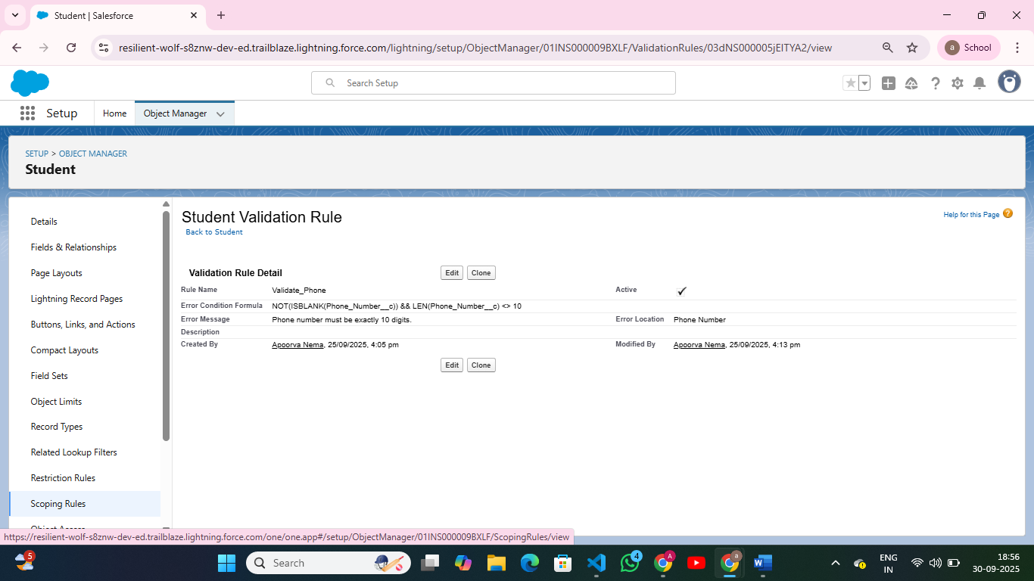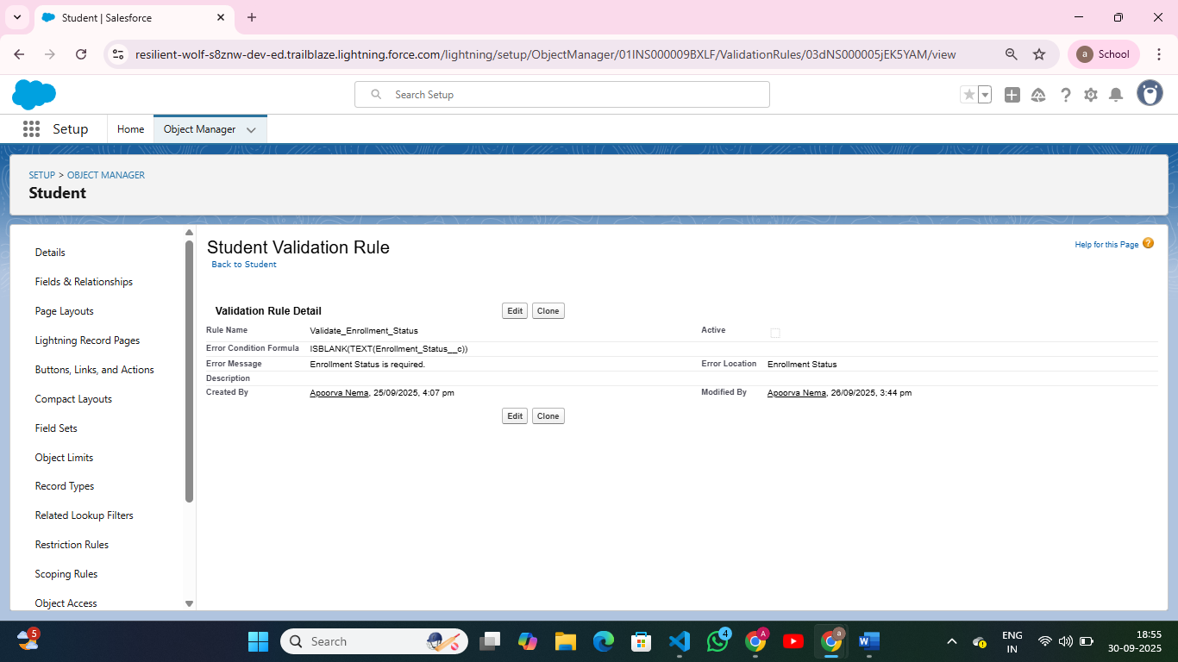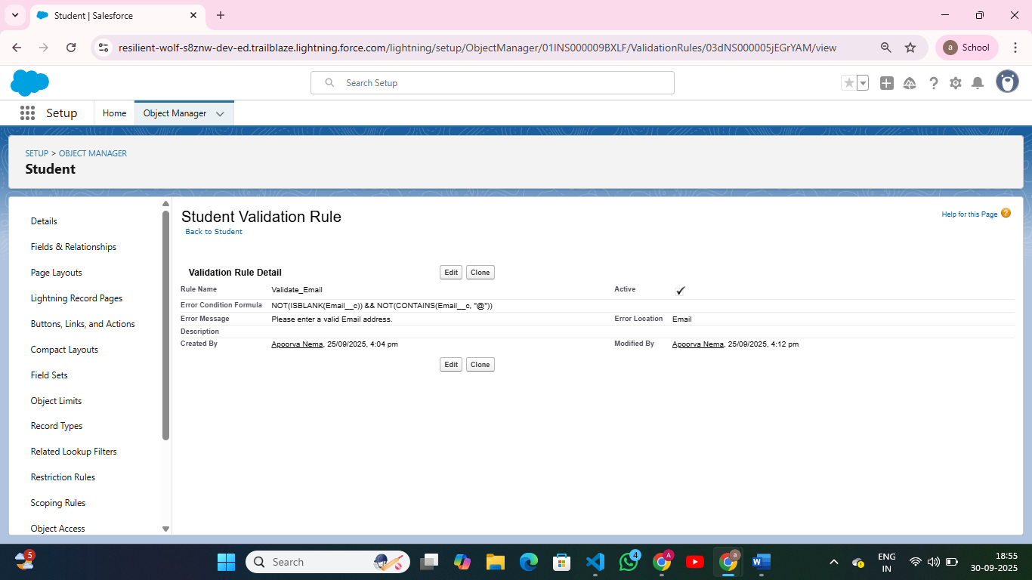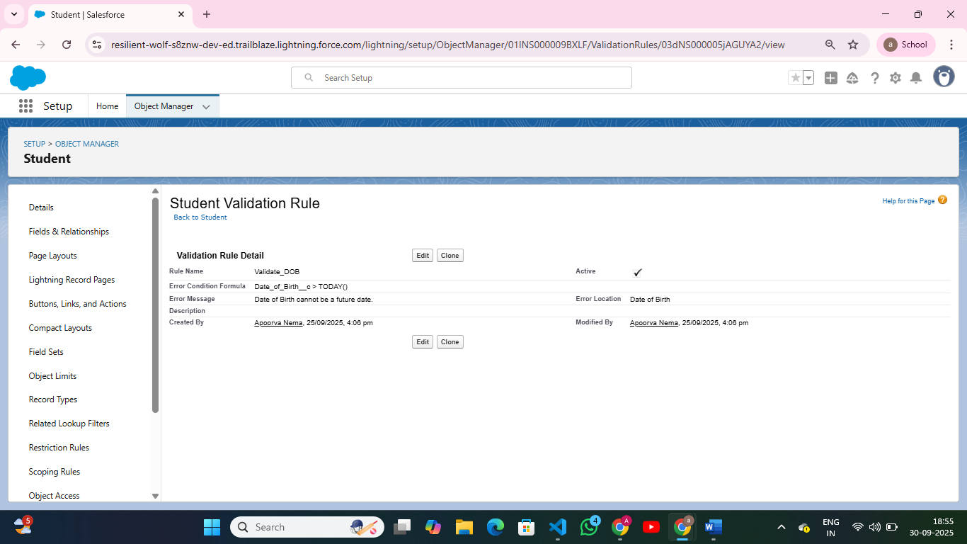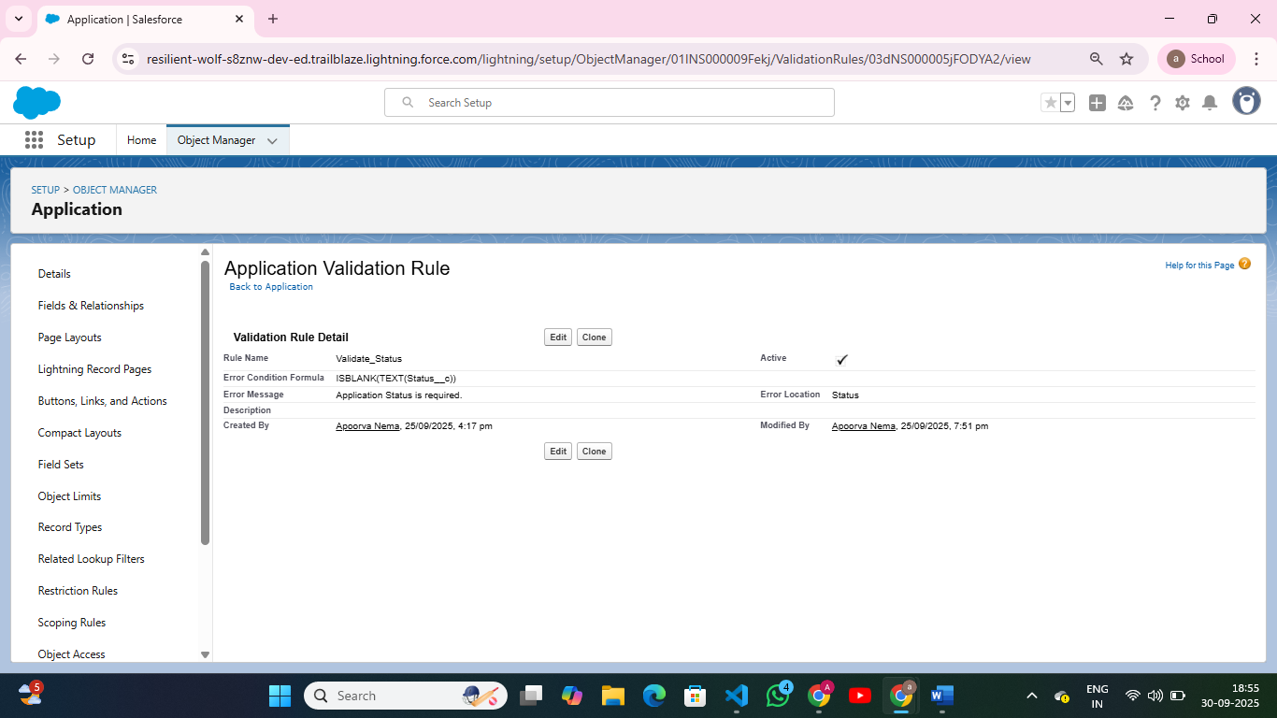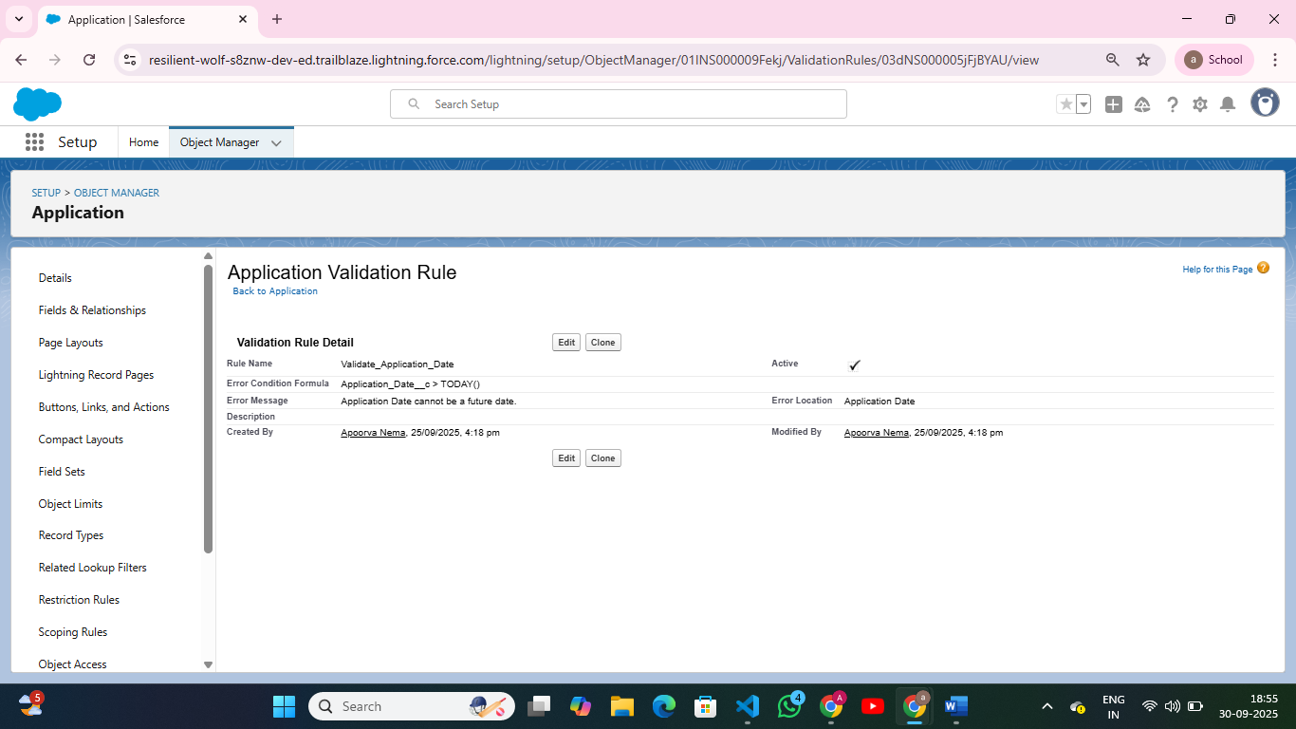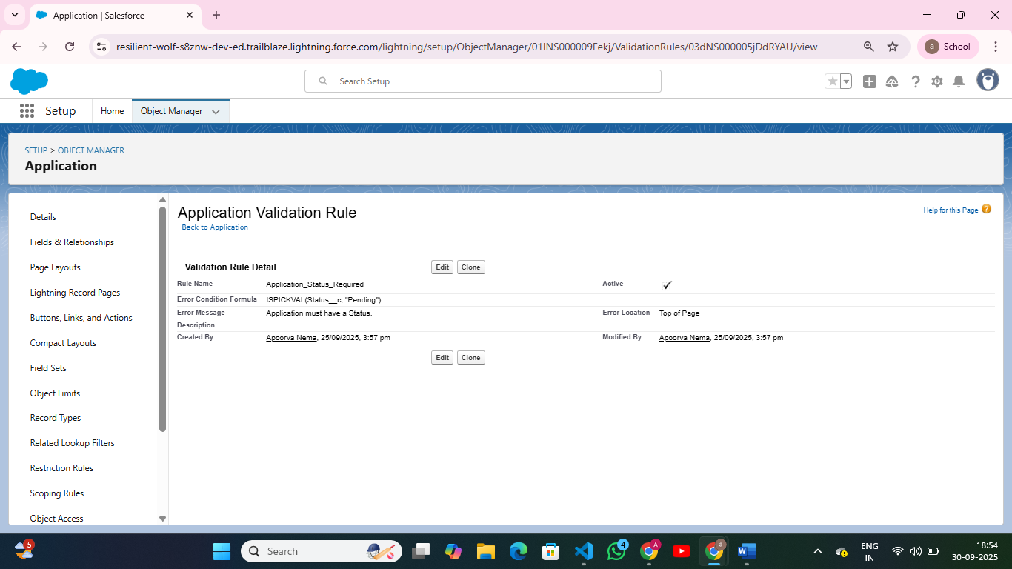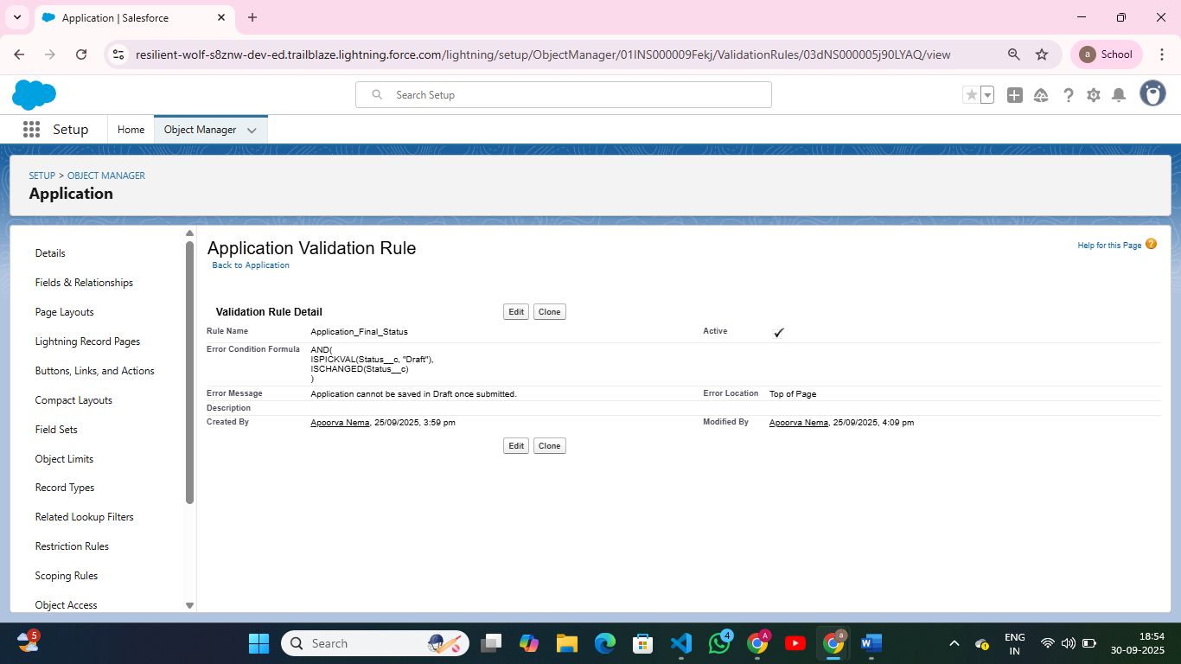

**2. Workflow Rules**

* Automate standard actions like sending emails, updating fields, or creating tasks.
* Setup → Workflow Rules → New Rule → Select Object → Set Criteria → Add Workflow Action (Email Alert, Field Update, Task, Outbound Message).

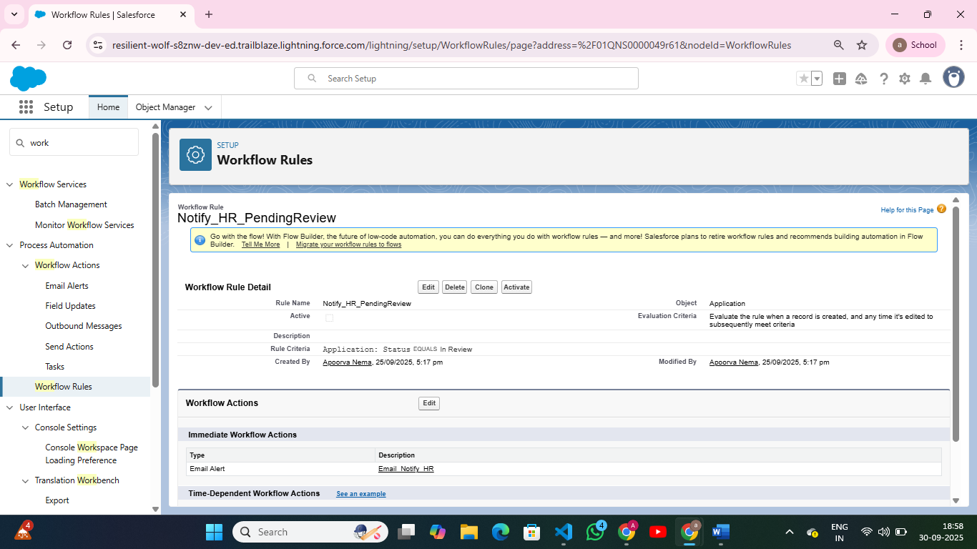

**3. Process Builder**

* Visual tool for multi-step automation using clicks instead of code.
* Setup → Process Builder → New → Select Object → Define Criteria → Add Actions (Create Record, Update Record, Email Alert).

**4. Approval Process**

* Automate record approvals with multiple steps and assigned approvers.
* Setup → Approval Processes → Select Object → Create New Approval Process → Define Entry Criteria → Assign Approvers → Specify Actions on Approval/Reject

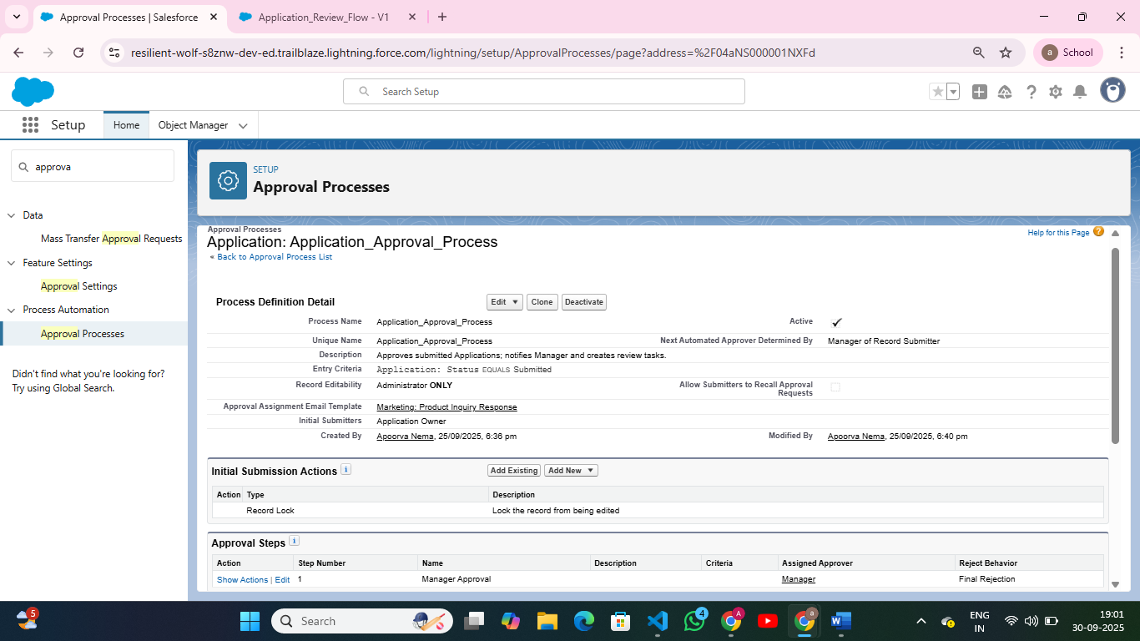

**5. Flow Builder**

* Powerful automation tool for building screens, logic, and record updates.
* Setup → Flows → New Flow → Select Type → Drag Elements (Screen, Assignment, Update Records).

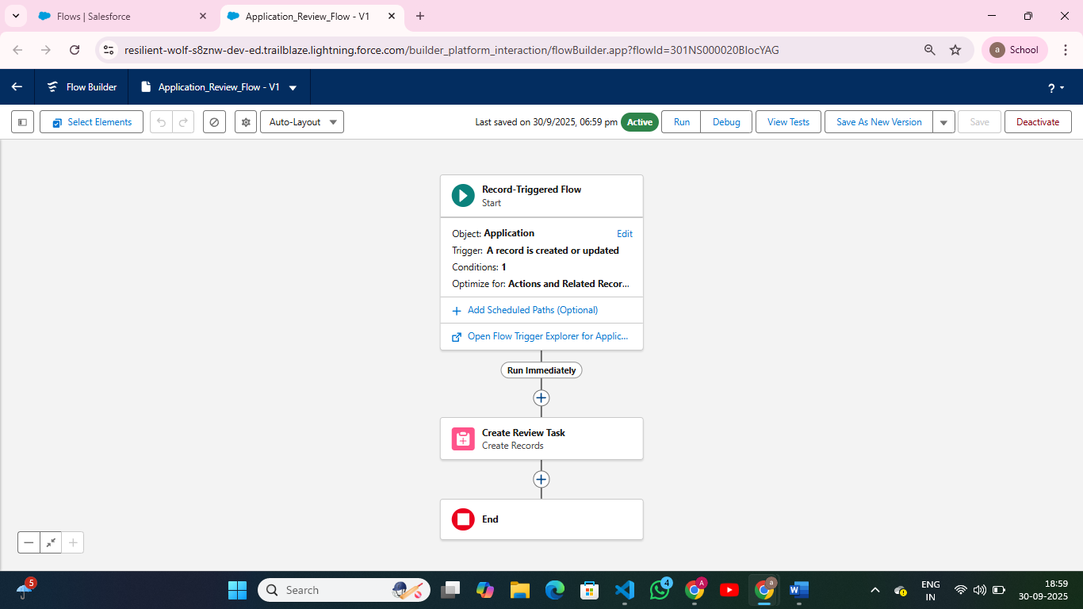

**6. Email Alerts**

* Send emails automatically based on workflow/process criteria.
* **Navigation**: Setup → Email Alerts → New → Select Object → Define Recipient → Choose Email Template.

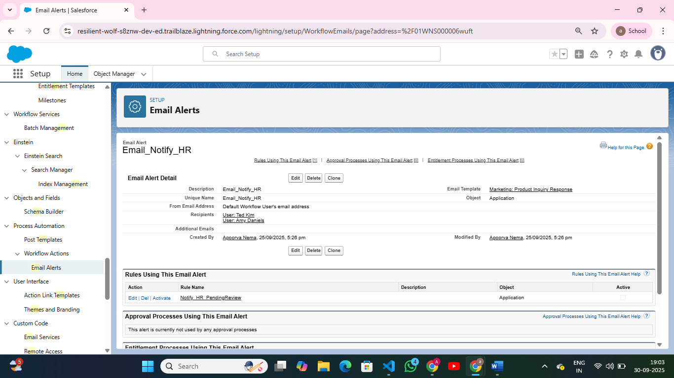

**7. Field Updates**

* Automatically update field values when criteria are met.
* **Navigation**: Setup → Object Manager → [Select Object] → Fields & Relationships → New → Field Update → Set Value.

**8. Tasks**

* Automatically create tasks for users as part of automation.
* **Navigation**: Setup → Workflow Rules / Process Builder → Add Action → Create Task → Assign to User or Role.

**9. Custom Notifications**

* Push notifications to users in Salesforce or mobile app.
* **Navigation**: Setup → Notification Builder → Custom Notifications → Create New → Add to Flow / Process.